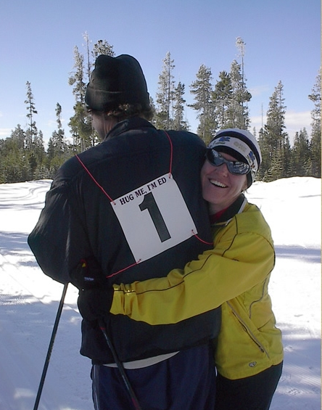
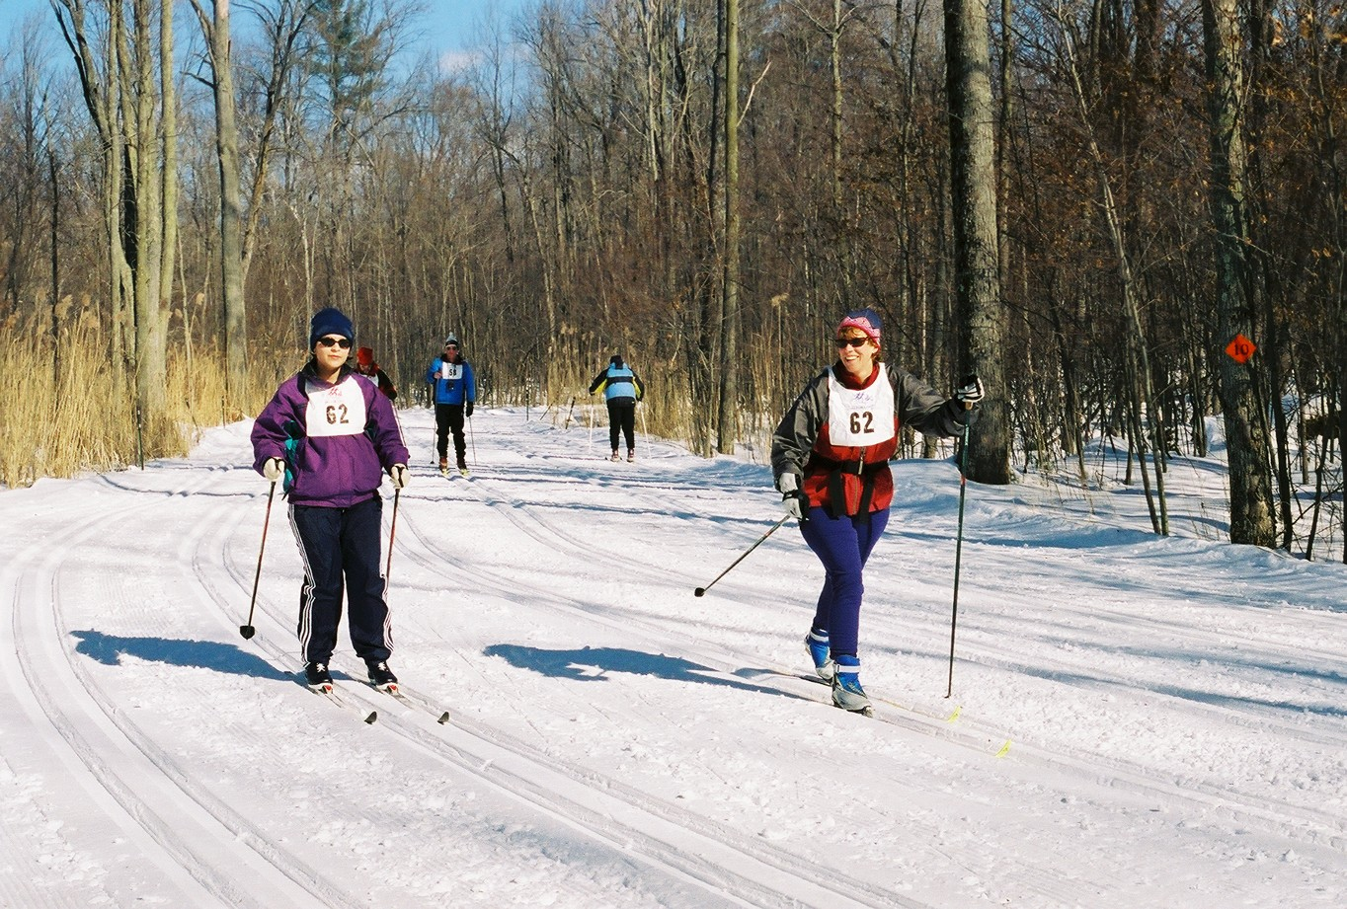
Share Your Passion!
Change a Life!

SKI FOR LIGHT 2008

Come Join Us In Bend

Sunday, February 10-Sunday, February 17, 2008, Bend, Oregon

Ski for Light, Inc. (SFL), an all-volunteer nonprofit organization, conducts a week long program to teach blind and mobility-impaired adults the sport of cross-country skiing. Each disabled participant is paired with an experienced cross-country skier for six days of instruction, practice and fun on the snow. SFL attracts more than 250 active adults from every corner of the U.S. and from around the world. This year’s 33rd annual Ski for Light International Week will take place in Bend, Oregon, from Sunday, February 10 through Sunday, February 17, 2008. Participants will ski at Mt. Bachelor and stay at the Riverhouse Resort Hotel.

Join us as a volunteer! Guides and other volunteers are needed for the week. Applications and more information about Ski for Light are available online at www.sfl.org or from Guide Coordinator Brenda Seeger at BrendaS@sfl.org, (507) 274-5502.

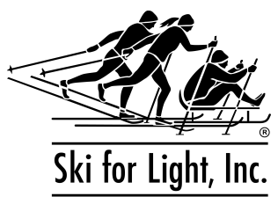

The experience of a lifetime awaits you!

www.sfl.org
(612) 827-3232

