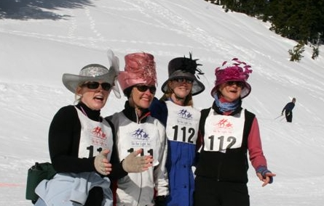
Share the Passion!

Share the Fun!

SKI FOR LIGHT 2009

Sunday, February 1 - Sunday, February 8, 2009
Provo and Soldier Hollow, Utah

Ski for Light, Inc. (SFL), an all-volunteer nonprofit organization, conducts a week long program to share the sport of cross-country skiing with blind and mobility-impaired adults. Each disabled participant is paired with an experienced cross-country skier for six days of instruction, practice and fun on the snow. Off the snow activities include a welcome reception, auction and talent night. SFL attracts more than 250 active adults from across the U.S. and around the world. This year’s 34th annual Ski for Light International Week will take place in Utah, from Sunday, February 1 through Sunday, February 8, 2009. Participants will ski at Soldier Hollow Cross-Country Ski Resort, site of the 2002 Olympic cross-country skiing and biathlon events, and stay at the Marriott Hotel & Conference Center in Provo.
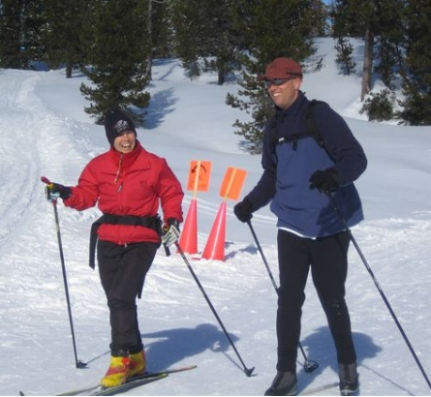
Guides and other volunteers are needed for the week. Applications and additional information about Ski for Light is available online at www.sfl.org,
or from Guide Coordinator Brook Yates at brookyates.sfl@gmail.com (970) 333-4035,
or Brenda Seeger at seegerb@hotmail.com, (218) 253-2010.

The experience of a lifetime awaits you!
www.sfl.org
(612) 827-3232

